Economic Development Updates 2021

New Businesses Opening/Relocating
- Memorial Healthcare of Owosso 3544 Meridian Crossing (Ribbon cutting 7/27)
- Williams Audi Volkswagen Jolly Road
- Lil Emil’s (Meridian Mall food court) Ribbon Cutting 7/7/2021
- Square One Breakfast

Under Construction
- Haslett Marathon-1619 Haslett Road-new building construction/approved Brownfield Plan
- Fedewa Homes-1730 Chief Okemos-residential project
- Red Cedar Manor-Commercial/Residential Development
- Sierra Ridge final plat extension approved
- Silverstone Estates—residential development Powell Road with Special Assessment District for the road final platting approved
- Copper Creek –First homes CofO
- Williams Volkswagen of Okemos
- High Caliber Karting expansion at Meridian Mall
- Joe's on Jolly 2360 Jolly Road (restaurant and fitness training center)

Approved/Not Commenced
- Woda Cooper submitted site plan approved
- Newton Park Apartments Multifamily mixed use Haslett Road (SE corner Okemos/Haslett)-approval for SUP extended for another year – proposed amendment partial approval
- Pine Village 1673 Haslett Road Commercial /Residential development approved
Meridian Township Brownfield Plan – proposed amendment to rearrange first floor
- Village of Okemos 4661 Okemos Road Commercial/Residential development
Approved EGLE Brownfield, Meridian Redevelopment Fund- Second amendment public hearing with Community Development Director.
- Buddy's Pizza--2010 Grand River building demolished week of 7/12
Closings/Postponements

Lil Emil’s Ribbon Cutting
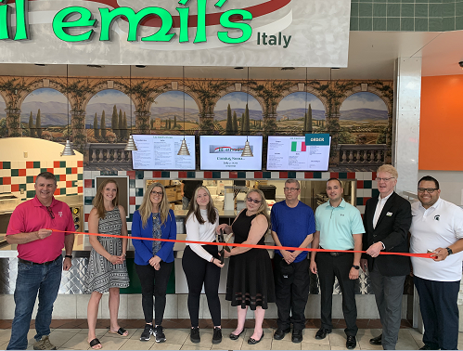
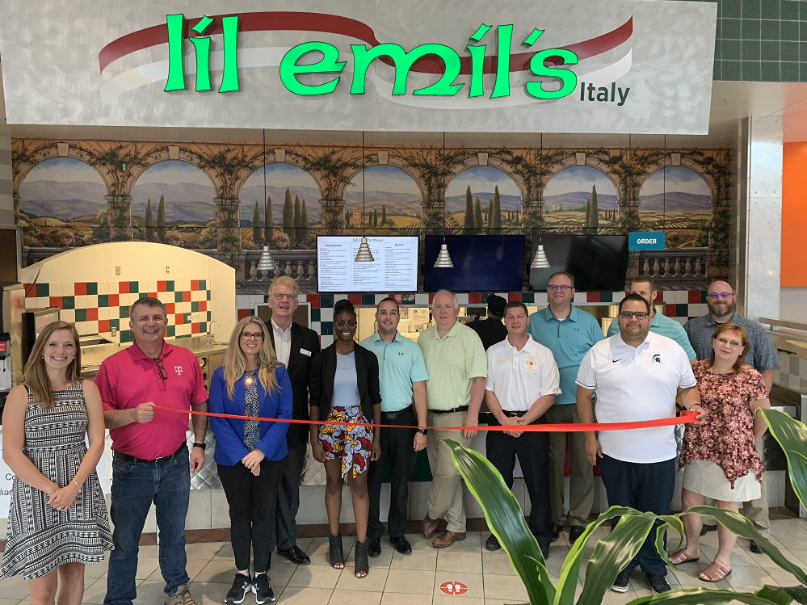

Marketplace on the Green Music Wednesdays
“Taylor Taylor”
